PERSONAL EXPENSE TRACKER APPLICATION

1. **INTRODUCTION**
   1. **Project Overview**:

Nowadays people are concerned about regularity of their daily expenses. This is done mainly for keep a track of the users’ daily expenses to have a control of their monthly expenses. As the traditional methods of budgeting, we need to maintain the Excel sheets, Word Documents, notes, and files for the user daily and monthly expenses. There is no as such full-fledged solution to keep a track of our daily expenses easily. Keeping a log in diary is a very monotonous process and also may sometimes lead into problems due to the manual calculations.

Looking on all the above given conditions, we are trying to satisfy the user requirements by building a application which will help them reduce their burdens. “Personal Expense Tracker Application” is an application where one can enter their daily expenses and end of the day, they know their expenses in charts. Personal Expense Tracker app will not only help you with budgeting and accounting but also give you helpful insights about money management.This applications will ask users to add their expenses and based on their expenses, wallet balance will be updated which will be visible to the user.  Also, users can get an analysis of their expenditure in graphical forms. They have an option to set a limit for the amount to be used for that particular month if the limit is exceeded the user will be notified with an email alert.

**1.2 Purpose:**

This application will help us to reduces the manual calculations for their daily expenses and also keep the track of the expenses. With the help of this application, user can calculate his total expenses per day and these results will stored for unique user.

1. **LITERATURE SURVEY**
   1. **Existing problem**
2. Income and Expense Tracker will maintain data of daily, weekly, monthly, yearly expenses, Manages user’s expenses and earnings in a simple and intuitive way. User can select category of expense, enter other information like user can capture photo, add location, select amount of expense etc. And this will save to the local database. User can view and sort expense as per weekly, monthly, yearly. By using this, the system can reduce the manual calculations for their expenses and keep the track of the expenditure. In this, user can provide his income to calculate his total expenses per day and these results will stored for unique user. People when usually go for trips or movies with friends they can use this tracker to maintain their expense. It will be easy for them to share the bill in this tracker.This will display graph as per selected view. And user can enter his monthly income or limit of monthly Expense in this tracker. This tracker system provides an integrated set of features to help user to manage the expenses and cash flow.But this project will not have any reminder to remain a person in a specific date, so that is the only drawback in which the remainder is not present.This project will be an unpopulated data because it has some disadvantages by not alerting a person for each and every month. But it can used to perform calculation on income and expenses to overcome this problem we propose the new project.
3. Income and Expense Tracker which is helpful to manage out income and expense as an daily or periodically or else whenever want to remind. It also act as an indicator or reminder example in the fastest world which can’t able to remember what are the things people have to do for the end of month and what are the payments have to pay for the particular month. Due to some conflict or some other stress people forget some times that what are the income or where the money has to come from or what the payments have to pay. This application will help you to make a note for what or the things user have to do for the end of month. For example, like how much it expenses for monthly and what are the expenses for a month. Some of the expense features like food expenses billing expenses like phone, electricity, taxation and some other personal expenses.
4. Expense Tracker is a day-to-day expense management system designed to easily and efficiently track the daily expenses of unpaid and unpaid staff through a computerized system that eliminates the need for manual paper tasks that systematically maintains records and easily accesses data stored by the user.Expense Tracker app is usable by anyone who are willing to manage their expenses and aiming to save for the future investments. This app has no range criteria or any kind of profession or gender are focused so it will used hugely by any other person.This system is developed to work without internet and design the window application in such a way that the user does not have to bother using this application without much effort. End users with window running devices can use this software.If the users are a window user then can download the application and work accordingly. This system is used by any person to control their income expenditure from daily to annual basics and to keep an eye on their spending. This system can be used in mutli-language. The main feature of this system is to track by day and category.
5. This system is very helpful to the smartphone users and make their life easy. The expense manager application is one among those applications, which provides a variety of help in daily life. As there are many similar applications available trying to solve the same problem but are not effective, here are some added innovative features to make the application unique, easy to use and efficient, this is what makes the application standout from the rest of others. Other than adding unique features like integrating group expenses and personal expenses into one single application, also add features like trends and estimations. This system also includes syncing of applications with personal email IDs or social network account which help also help to serve better recommendations and personalised marketing campaigns.The main features of this system are keep track of all daily transactions, keep track of money lent or borrowed, Suggest the user with the best investment options, offers in popular categories, helps to view stock market and also helps to read latest authenticated financial news.The application delivered efficiently in calculating split expenses and recording the expenses together accurately with date and time.
6. Daily Expense Tracker is a small rule in imitation of successfully bossing one’s costs easily. It is raised in imitation of superintending the daily expenses in an extra efficient and manageable way. By using the software, decrease the guide calculations regarding-by-day by fees care of period these effects desire stay stored because of each user. Daily Expense Trackers lets in the person in accordance with hold a computerized diary. It is an application as users do accomplish between their computers. It is capable after begetting one’s fees yet deliverance document so care of duration up to expectation be able to keep selected. Daily Expense Tracker is chronic by someone character in imitation of rule one’s income-expenditure of daily groundwork upon after the end regarding the month longevity. The essential function that utility is so much can tune costs by looking out the date, month, or year. Daily Expense Tracker helps in figuring out fraud, with India mildly moving according to digital charge such is vital you maintain close tune regarding your savings visiting card statements, financial institution debts yet spend. Otherwise, execute read exhaust according to monetary fraud and no longer even realize it. This challenge also offers half possibilities that choice help the person by maintaining all pecuniary things to do kind of digital computerized diary. This software is entirely effortless in imitation usage and that have multi-language features. The important characteristic about this application is that amount that perform than expense by means of citing date, month yet year. It utilizes according to preserve than expenses then additionally enhance your savings.
7. This system is for keeping track of earnings. Expense Tracker is a tool that can assist anyone in keeping track of their expenses and reducing their spending. Expense Tracker where users may download to their phones and use to track and update their daily costs so they are always aware of how much they are spending. The user can establish their own spending categories, such as food, clothing, rent, and bills, and then enter the amount spent as well as any notes. Include more information in the additional information area to specify the expense. A pie chart of costs will be available to the user. Every Day Expense Tracker System is a software programme that keeps track of a user's daily income and expenses. Overall, this is a smart automated solution for tracking expense.This system should be capable of analysing data provide information on the categories the user spent the most money in. The suggested system should have a user interface that allows users to save and track their previous expenses. Track money which is developed with a concept in mind to help users to easily manage all their income and expenses and keep track of all credits and debits of transaction according to different categories, also users can have a pictorial representation of all the transactions of different categories and can also download excel reports of transaction. Also receives customised tips in the form of push notifications which helps users to manage expenses.
8. The Real-time voice operated expense and transaction tracking application is a application that acts as a wallet to the people and tracks all the transaction and expenses that a person is doing in their daily life. This application is a voice command activated application that contributes in providing user interactive UI allowing the people to easily add and remove the money as per the required date. This is a totally automatic website that works on voice command. A user using the application can see a wide range of features in respective categories. This application each user a satisfaction for the login and safety of each and every particular user also its very user friendly and user oriented application.Many users in their daily life try to save money in order to save money and use that for further use. Therefore in order to simplify their work and help them to save money and track their expense this application is the best practice to work with. With the rapid development of cost and expense, it will try to save money so if user is not able to track the expense or find difficulty in having the record then user can use the application for their personal use and save as much they want because this will help one to have daily expense record. Money wastage irritates every person while doing purchase. So, in expense tracking app there will be no case of wastage of money.
9. Nowadays there are a wide range of spreadsheets and projects that are intended to make your financial planning that are meant to make a lot easier and more proficient. This system overcomes by addressing the complexity of tracking income and expenses by introducing budget tracking application developed for high performance. The result indicated the need of solution to ease the task. Budget tracking native mobile application with interactive user interface and with handy features would be one of the ideal solutions for the current problem. User centered applications require user feedback by delivering prototype version to the real users. This application is known for its performance, reliability and user friendliness. This system’s solution will make positive impact on people’s day to day life by making use of the budget tracking application’s promising features. The drawback is further research may be needed in order to identify other factors that could strengthen the effectiveness as features are sometimes inactive.
   1. **References**
10. Chandini, S., Poojitha, T., Ranjith, D., Akram, V. M., Vani, M. S., & Rajyalakshmi, V. (2019). Online Income and Expense Tracker. International Research Journal of Engineering and Technology (IRJET), 6(3), 2395-0056.
11. Thanapal, P., Patel, M. Y., Raj, T. L., & Kumar, J. S. (2019). Income and expense tracker. Indian Journal of Science and Technology, 8(S2), 118-122.
12. Gupta, H., Singh, A. P., Kumar, N., & Blessy, J. A. (2020). Expense Tracker: A Smart Approach to Track Everyday Expense (No. 4809). EasyChair.
13. Velmurugan, A., Mayan, J. A., Niranjana, P., & Francis, R. (2020, December). Expense manager application. In Journal of Physics: Conference Series (Vol. 1712, No. 1, p. 012039). IOP Publishing.
14. Masendu, T. R., & Tripath, A. M. (2021). Daily Expense Tracker. International Journal of Research in Engineering, Science and Management, 5(5), 90-92.
15. Jadhav, N. J., Chakor, R. V., Gunjal, T. M., & Pawar, D. D. (2021) EXPENSE TRACKER.
16. Sharma, S., & Verma, P. (2021). VOICE OPERATED REAL TIME EXPENSE TRACKER.
17. Hezretov, M. (2021). Budget Tracker Highly Customizable.

**2.3 Problem Statement Definition**

|  |  |  |  |  |  |
| --- | --- | --- | --- | --- | --- |
| **Problem Statement (PS)** | **I am (Customer)** | **I’m trying to** | **But** | **Because** | **Which makes me feel** |
| PS-1 | An Entrepreneur | Manage the finances more efficiently | I often forget many hidden costs of running a business | Insufficient knowledge about how much it costs to run the business | Depressed and unable to track my cash flows efficiently to stay competitive |
| PS-2 | An Employee | Manage the monthly expenses | Couldn’t have control over the income and expenditure | I often purchase branded items so cannot limit my expenses | No one to monitor the income and control the expenditure. |
| PS-3 | A Student | Spend my part time job salary for rent, shopping and some other additional expenses. | Cannot find a clear graph of my expenses as my income varies for every month | My income is based on the number of client I approach | Unable to track the expenses which makes me feel low |

1. **IDEATION & PROPOSED SOLUTION**
   1. **Empathy Map Canvas**

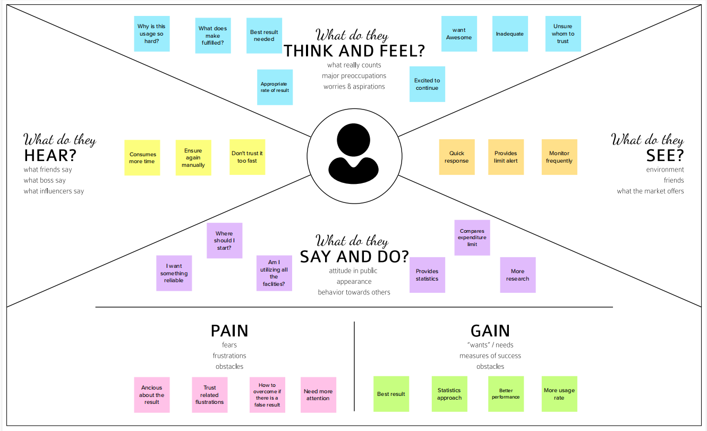

* 1. **Ideation & Brainstorming**

;

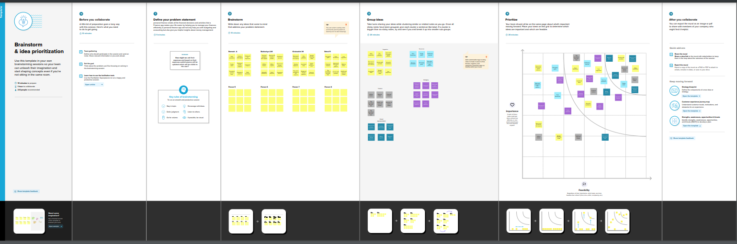

**3.3 Proposed Solution:**

1. PROBLEMSTATEMENT: Agriculture being the economy of India, crops, plants, trees etc should be nourished to increase the economy without a backdrop. Though there are lot of problems that arise from the root node till the leaf or bud, which are called as the plant disease. These problems in plants can be predicted and further recommendation of fertilizers can be rendered to make the plant healthy
2. IDEA/SOLUTIONDESCRIPTION: The idea for the problem stated above can be solved by an automated disease prediction system that recommends the fertilizer to its customers. The pesticides can be recommended by comparing the current diseased pictures uploaded by the customers and a healthy picture. The recommendation of pesticides/fertilizers does not stop there but also leveraged by suggesting the shops that have the inventory of the recommended fertilizer.
3. NOVELTY/UNIQUENESS: The solution to be developed will have a super-fast response when compared to the other applications on the web today. There are many applications that provide health advisory, calendar guides and guest speaker talk. But this application will predict the plant infection and will also suggest a healthy measure of recovering it to a healthy state.
4. SOCIAL IMAPACT/CUSTOMER SATISFACTIO: The application will be a major assistance for the farmers and people intrigued in the field of agriculture. For ex: There is a statistic that accounts on more than 15 Million downloads for an app named plantix. The level of customer satisfaction will simply be immeasurable as the yield increases and the automated work together provides an utmost customer satisfaction.
5. BUSINESS MODEL: Increase in the users are directly proportional to the download rate that ultimately rises the revenue of the developer and the future growth of agriculture will always be in a boom irrespective of the technology diversities.
6. SCALABILITY OF SOLUTION: The solution proposed can be used only to predict the plant disease or only to know the inventory of fertilizers in the shops nearby. The SAAS model will be easy to use interface alongside of being a franchise model.

**3.4 PROPOSED SOLUTION FIT**

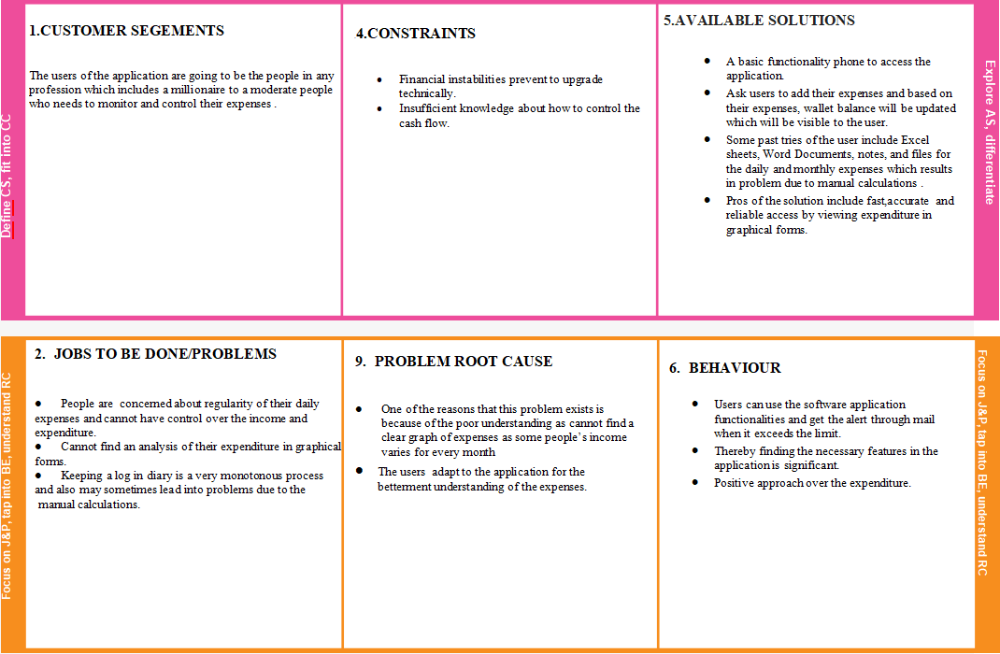

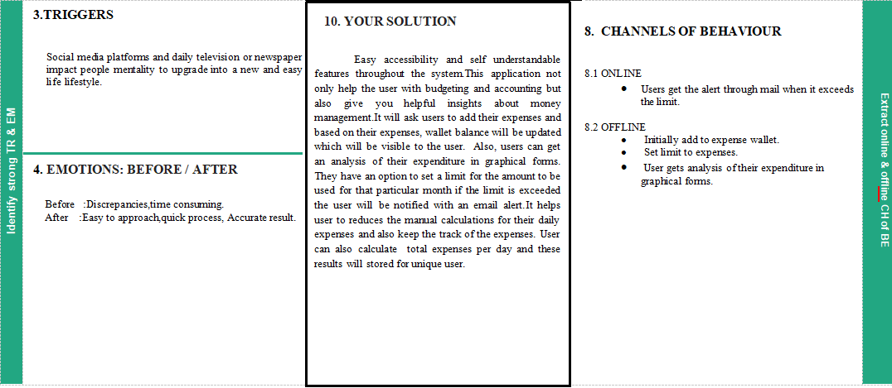

1. **REQUIREMENT ANALYSIS**
   1. Functional requirement

|  |  |  |
| --- | --- | --- |
| **FR No.** | **Functional Requirement (Epic)** | **Sub Requirement (Story / Sub-Task)** |
| FR-1 | User Registration | Registration through Form,  Registration through Email,  Profile built. |
| FR-2 | User Confirmation | Confirmation via text message  Confirmation via Email |
| FR-3 | Role of User | Add expenses to wallet  Set limit to avoid exceeding |
| FR-4 | Role of application | Analysis of expenditure in graphical forms  When the limit is exceeded, the user will be notified with an email alert. |
| FR-5 | Result | Reduces the manual calculations for daily expenses and also keep track of the expenses  Calculate total expenses per day and the results will stored for unique user. |

* 1. Non-Functional requirements

|  |  |  |
| --- | --- | --- |
| **FR No.** | **Non-Functional Requirement** | **Description** |
| NFR-1 | **Usability** | The application provides simple and clear functionality such as graphical representation of the expenses and provides alert when the limit is reached. |
| NFR-2 | **Security** | User information will be safe.The registered user information will not be shared to other users. |
| NFR-3 | **Reliability** | The trust towards the system is high as it eventually provides accurate results. |
| NFR-4 | **Performance** | The user does not have to wait long for accessing the result as it performs consistently well. |
| NFR-5 | **Availability** | The application is user friendly which can be easily accessed by the user irrespective of time. |
| NFR-6 | **Scalability** | The application is designed in such a way it can able to withstand huge number of users at any moment. |

1. **PROJECT DESIGN**
   1. Data Flow Diagrams

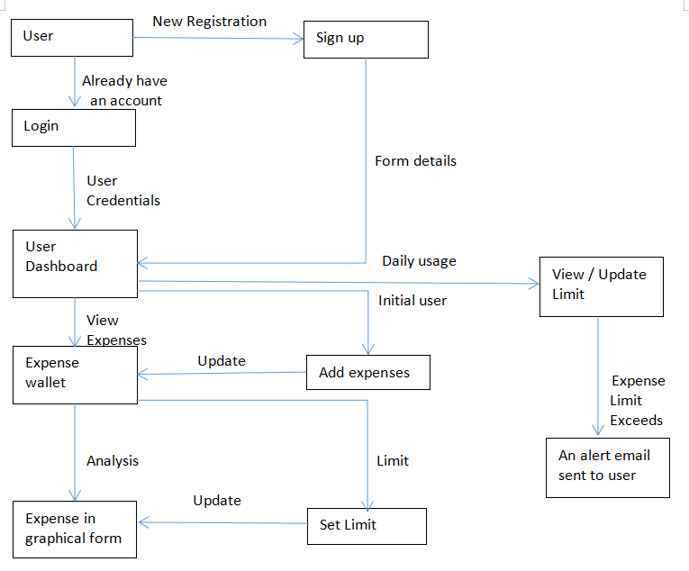

* 1. Solution & Technical Architecture

Solution Architecture

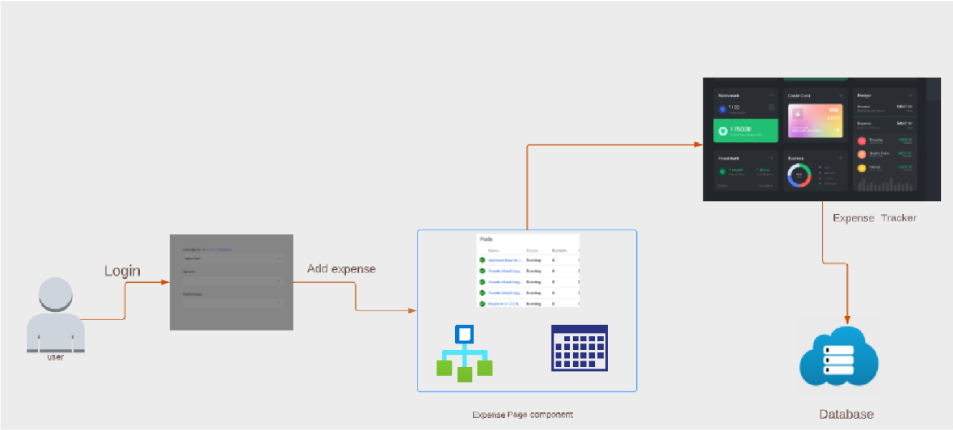

Technical Architecture

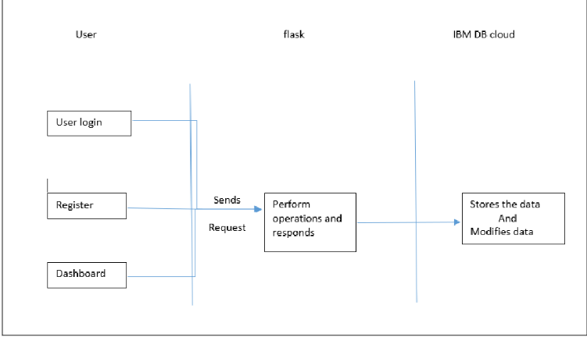

5.3 User Stories

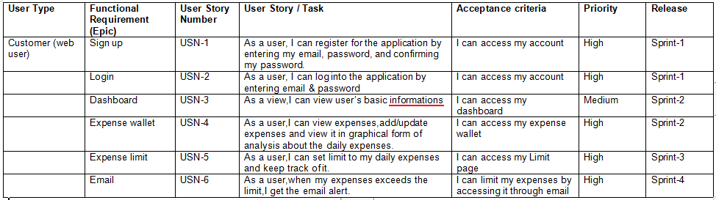

1. **PROJECT PLANNING & SCHEDULING**
   1. Sprint Planning & Estimation

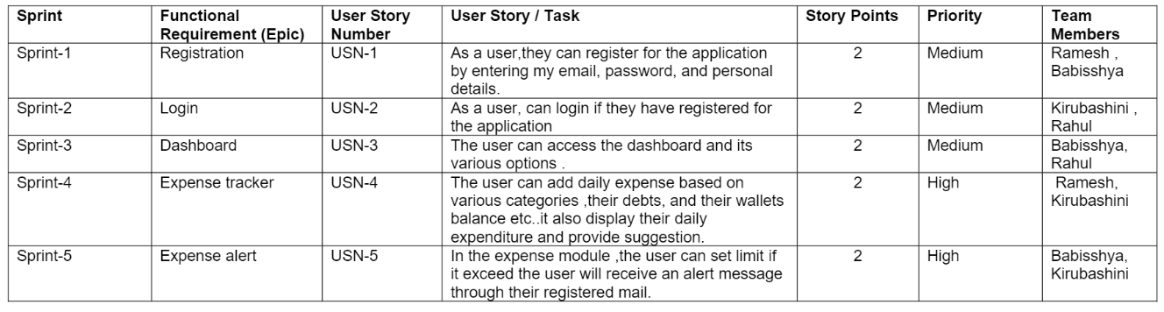

* 1. Sprint Delivery Schedule

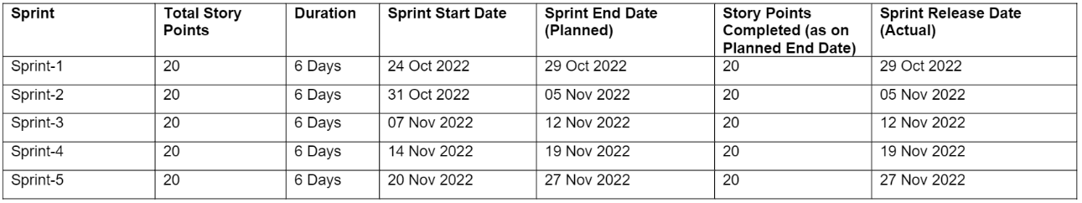

* 1. Reports from JIRA

RoadMap:

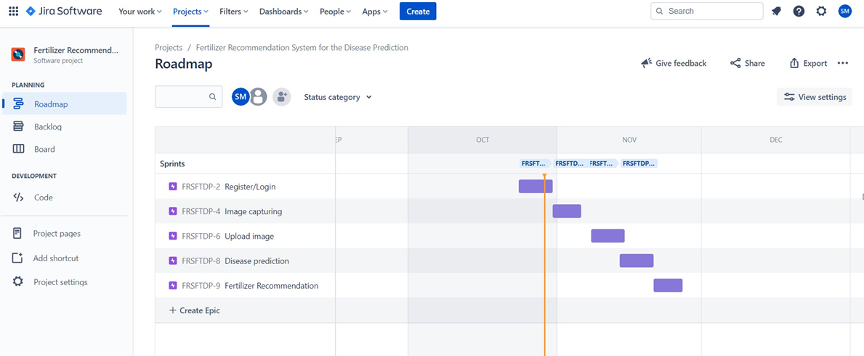

1. **CODING & SOLUTIONING (Explain the features added in the project along with code)**
   1. Feature 1

Users can have separate accounts for them to make sure that they have expenses noted exclusively for them.

* 1. Feature 2

Categories can be created to categorize expenses recorded on a daily basis.

7.3Feature 3

Daily limit can be set to expenses, so whenever the daily limit is exceeded, a mail will be sent to the user to notify the exceedance of limit.

7.4Database Schema (if Applicable)

User

* Id
* Name
* Email
* Password
* Limit

Category

* Id
* Name
* Color
* User id

Expense

* Id
* Name
* Amount
* Category Id

1. **TESTING**
   1. Test Cases

8.2 User Acceptance Testing

1. **RESULTS**
   1. Performance Metrics

|  |  |  |  |
| --- | --- | --- | --- |
| **S.No.** | **Parameter** | **Values** | **Screenshot** |
| 1. | Model Summary | Total params: 38,160,755  Trainable params: 38,160,755  Non-Trainable params: 0 |  |
| 2. | Accuracy | Training Accuracy – 97.55 Validation Accuracy – 96.45 |  |

1. **ADVANTAGES & DISADVANTAGES**
2. One farm management approach which is precision agriculture can help farmers grow more crops with fewer resources. Precision agriculture powered by AI could become the next big thing in farming. Precision farming combines the best soil management practices, variable rate technology, and the most effective data management practices to help farmers maximize yields and minimize spending.
3. AI can provide farmers with real-time insights from their fields, allowing them to identify areas that need irrigation, fertilization, or pesticide treatment. Also, innovative farming practices like vertical agriculture may help increase food production while minimizing the use of resources. The result is reduced use of herbicides, better harvest quality, higher profits, and significant cost savings.
4. Agricultural work is hard, and labor shortages in this industry are nothing new. Farmers can solve this problem with the help of automation. Driverless tractors, smart irrigation and fertilizing systems, smart spraying, vertical farming software, and AI-based robots for harvesting are some examples of how farmers can get the work done without having to hire more people. Compared with any human farm worker, AI-driven tools are faster, harder, and more accurate.
5. Farmers need to understand that AI is only an advanced part of simpler technologies for processing, gathering, and monitoring field data. AI requires a proper technology infrastructure for it to work. That is why even those farms that already have some technology in place can find it difficult to move forward.
6. This is also a challenge for software companies. They should approach farmers gradually, giving them simpler technology first, such as an agriculture trading platform. Once farmers get used to a less complicated solution, it will be reasonable to step it up and offer something else, including AI features.
7. The agricultural sector in developing countries is different from the agricultural sector in Western Europe and the US. Some regions could benefit from artificial intelligence agriculture, but it may be hard to sell such technology in areas where agricultural technology is not common. Farmers will most likely need help adopting it.
8. Therefore, tech companies hoping to do business in regions with emerging agricultural economies might need to take a proactive approach. In addition to providing their products, they will have to provide training and ongoing support for farmers and agribusiness owners who are ready to take on innovative solutions.
9. Since there are no clear policies and regulations around the use of AI not just in agriculture but in general, precision agriculture and smart farming raises various legal issues that often remain unanswered. Privacy and security threats like cyberattacks and data leaks may cause farmers serious problems. Unfortunately, many farms are vulnerable to these threats.
10. **CONCLUSION**

Different approaches and models of Deep Learning methods were explored and used in this project so that it can detect and classify plant diseases correctly through image processing of leaves of the plants. The procedure starts from collecting the images used for training, testing and validation to image preprocessing and augmentation and finally comparison of different pretrained models over their accuracy. Finally, at the end, our model detects and distinguishes between a healthy plant and different diseases and provides suitable remedies to cure the disease. This paper proposed and developed a system which uses plant leaf images to detect different types of disease in tomato crops, and also provides appropriate fertilizer suggestions.

1. **FUTURE SCOPE**

The system successfully interprets various Diseases and is also capable of providing fertilizers suggestion for the respective disease. Furthermore, this system can be made more robust by incorporating more image dataset with wider variations like more than one leaf in a single image. An App could also be developed for the project which could make the work of the farmers easier. They could directly upload image on the app and it would tell the disease and the cure then and there. This would reduce the time and efforts. This project is limited to just one crop for now but in the future more crops and even flowers dataset can be added so that it is helpful for every agricultural need. Newer models can also be added and tried with time which may result in better accuracy and would make the model even faster.

1. **APPENDIX**

Source Code

GitHub & Project Demo Link